import
pandas
as
pd
import
numpy
as
np
import
re
import
matplotlib.pyplot
as
plt
from
wordcloud
import
WordCloud
from
sklearn.feature_extraction.text
import
TfidfVectorizer
from
nltk.corpus
import
stopwords
import
nltk
nltk.download(
'stopwords'
)
[
nltk_data] Downloading package stopwords to /root/nltk_data...
[
nltk_data] Unzipping corpora/stopwords.zip.
True
df = pd.read_csv
(
"
/content/twitter_datas
df.head
(
)
Tweet_ID
Username
Text
Retweets
Likes
Timestamp
0
1
julie81
Party least receive say or single. Prevent pre...
2
25
2023-01-30 11:00:51
1
2
richardhester
Hotel still Congress may member staff. Media d...
35
29
2023-01-02 22:45:58
2
3
williamsjoseph
Nice be her debate industry that year. Film wh...
51
25
2023-01-18 11:25:19
3
4
danielsmary
Laugh explain situation career occur serious. ...
37
18
2023-04-10 22:06:29
4
5
carlwarren
Involve sense former often approach government...
27
80
2023-01-24 07:12:21
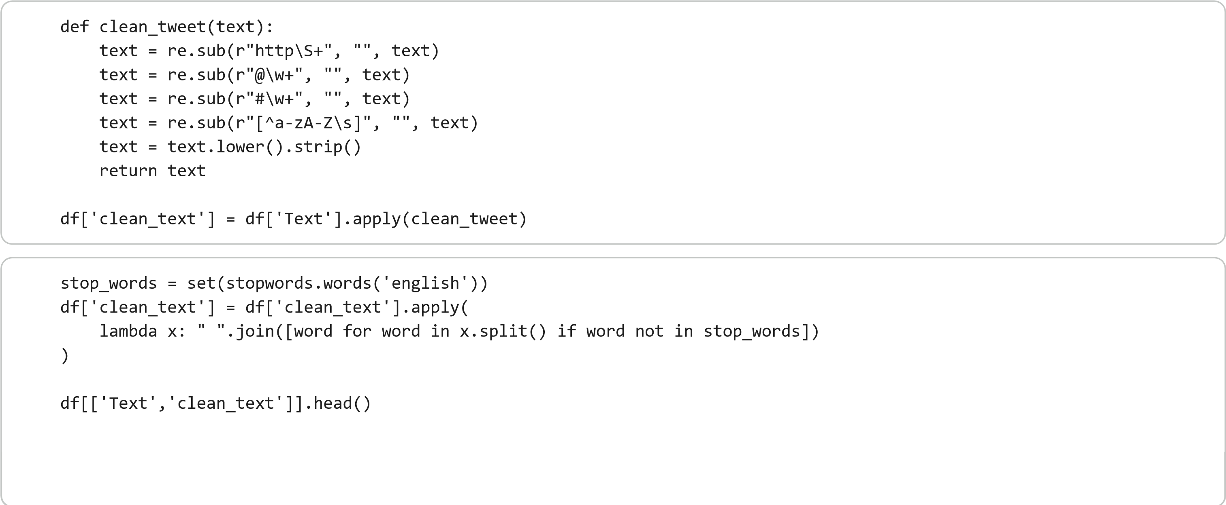
Text
clean_text
0
Party least receive say or single. Prevent pre...
party least receive say single prevent prevent...
1
Hotel still Congress may member staff. Media d...
hotel still congress may member staff media dr...
2
Nice be her debate industry that year. Film wh...
nice debate industry year film generation push...
3
Laugh explain situation career occur serious. ...
laugh explain situation career occur serious f...
4
Involve sense former often approach government...
involve sense former often approach government...
vectorizer = TfidfVectorizer(max_features=
5000
)
tfidf_matrix = vectorizer.fit_transform(df[
'clean_text'
])
tfidf_df = pd.DataFrame(tfidf_matrix.toarray(), co
lumns=vectorizer.get_feature_names_out())
tfidf_df.head()
ability
able
accept
according
account
across
act
action
activity
actually
...
would
write
writer
wrong
0
0.0
0.0
0.0
0.0
0.0
0.0
0.0
0.0
0.0
0.0
...
0.000000
0.0
0.0
0.0
1
0.0
0.0
0.0
0.0
0.0
0.0
0.0
0.0
0.0
0.0
...
0.198325
0.0
0.0
0.0
2
0.0
0.0
0.0
0.0
0.0
0.0
0.0
0.0
0.0
0.0
...
0.000000
0.0
0.0
0.0
3
0.0
0.0
0.0
0.0
0.0
0.0
0.0
0.0
0.0
0.0
...
0.000000
0.0
0.0
0.0
4
0.0
0.0
0.0
0.0
0.0
0.0
0.0
0.0
0.0
0.0
...
0.000000
0.0
0.0
0.0
5
rows × 869 columns
all_tweets_clean = df[
'clean_text'
]
neg_vectorizer = TfidfVectorizer(max_features=
5000
)
neg_tfidf_matrix = neg_vectorizer.fit_transform(al
l_tweets_clean)
neg_scores = np.
sum
(
neg_tfidf_matrix.toarray(), axis
=
0
)
terms = neg_vectorizer.get_feature_names_out()
top_indices = neg_scores.argsort()[
-15
:][::
-1
]
top_terms = [(terms[i], neg_scores[i])
for
i
in
top_indices]
top_terms
[(
'hard', np.float64(71.41534929291903)),

(
'tax', np.float64(70.14749331144758)),

(
'scene', np.float64(68.64151786374853)),

(
'high', np.float64(68.55526056548001)),

(
'maybe', np.float64(68.52335127253716)),

(
'add', np.float64(68.4827306318259)),

(
'yard', np.float64(68.45616720332833)),

(
'senior', np.float64(68.44784533370833)),

(
'forget', np.float64(68.37092712543082)),

(
'food', np.float64(68.36181096915784)),

(
'success', np.float64(68.31790823032573)),

(
'job', np.float64(68.27858869587938)),

(
'young', np.float64(68.02581644631354)),

(
'man', np.float64(67.79450279096052)),

(
'agree', np.float
64(67.7487058985991))]
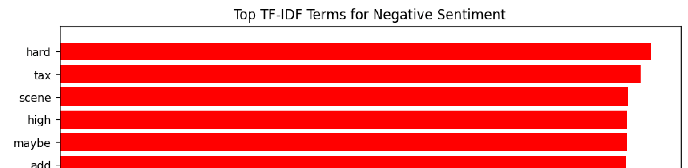
terms, scores =
zip
(
*top_terms
)
plt.figure(figsize=(
10
,
6
))
plt.barh(terms, scores, color=
'red'
)
plt.xlabel(
"TF-IDF Score"
)
plt.title(
"Top TF-IDF Terms for Negative Sentiment"
)
plt.gca().invert_yaxis()
plt.show()
wordcloud = WordCloud
(
width=
800
, height=
plt.figure
(
figsize=
(
12
,
6
)
)
plt.imshow
(
wordcloud, interpolation=
'bil
plt.axis
(
"off"
)
plt.title
(
"Word Cloud - All Tweets Vocab
plt.show
(
)
